 

Q1:

Software Requirements Specification

for

Bird Boarding Booking System

Version 1.0 approved

Prepared by

Bui Chi Cuong – YYXXXXXX

FU – XXX

02/04/2024

Q2:

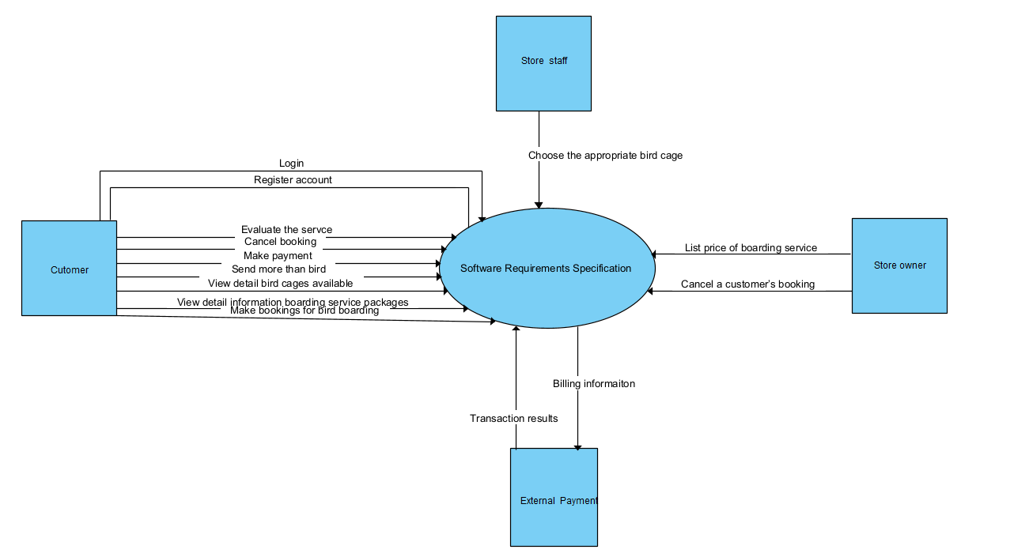

|  |  |  |
| --- | --- | --- |
| **#** | **Actor** | **Description** |
| 01 | Customer | A person who can make booking for birdboarding service, view detail information boarding service and bird cages availible, Send more than bird, making payment online, etc. |
| 02 | Store staff | The Store staff can choose the appropriate bird cage |
| 03 | Store owner | The store owner can list price of boarding service and cancel a customer’s booking |
| 04 | System payment online | The system allows the customer to make payment through PayPal or VnPay |

>

Q3:

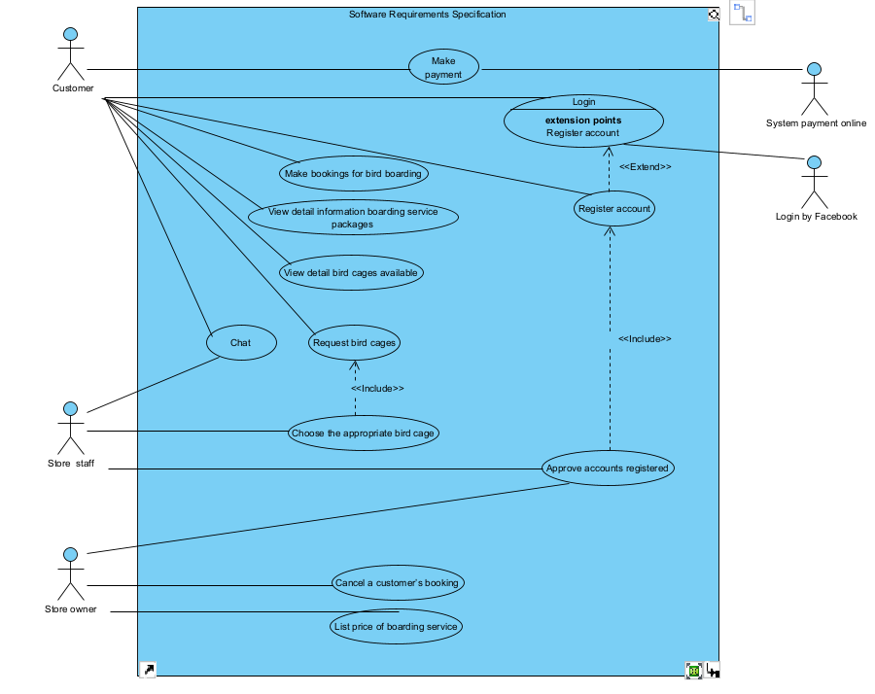

|  |  |  |
| --- | --- | --- |
| **#** | **Actor** | **Description** |
| 01 | Customer | A person who can make booking for birdboarding service, view detail information boarding service and bird cages availible, Send more than bird, making payment online, etc. |
| 02 | Store staff | The Store staff can choose the appropriate bird cage |
| 03 | Store owner | The store owner can list price of boarding service and cancel a customer’s booking |
| 04 | System payment online | The system allows the customer to make payment through PayPal or VnPay |

|  |  |  |  |
| --- | --- | --- | --- |
| **#** | **Use Case** | **Actors** | **Description** |
| UC-01 | Make bookings for bird boarding | Customer | Allow the customer make bookings for bird boarding |
| UC-02 | View detail information boarding service packages | Customer | Allow the customer view detail information boarding service packages |
| UC-03 | View detail bird cages available | Customer | Allow the customer view detail bird cages available |
| UC-04 | Choose the appropriate bird cage | Store staff | Allow the store staff choose the appropriate bird cage |
| UC-05 | Send more than bird | Customer | Allow the customer send more than bird |
| UC-06 | Make payment | Customer | Allow the customer Make payment |
| UC-07 | Cancel booking | Customer | Allow the customer Cancel booking |
| UC-08 | View history boarding booking process | Customer | Allow the customer View history boarding booking process |
| UC-09 | Evaluate the servce | Customer | Allow the customer Evaluate the servce |
| UC-10 | chat | Customer, store staff | The cus tomer can communicate with store staff through th system’s chat |
| UC-11 | List price of boarding service | Store owner | Allow the store owner list price of boarding service |
| UC-12 | Cancel a customer’s booking | Store owner | Allow the store owner cancel a customer’s booking |
| UC-13 | Login | Customer | Allow the customer login in the system |
| UC-14 | Request bird cages | Customer | The customer can specifically request bird cages in the store |
| UC-15 | Register account | Customer | Allow the customer can register their account |
| UC-16 | Approve accounts registered | Store staff, store owner | The customer account registered with the system must be approved by store staff or store owner |

Q4:

|  |  |  |
| --- | --- | --- |
| ID | Rule Definition | Use cases |
| BR-01 | The customer can choose the time period for depositing birds and the boarding service when booking a boarding service | UC-01 |
| BR-02 | The boarding service price is calculated for one bird/cage/day |  |
| BR-03 | The customer watns to send more than one bird in the same cage, the price will be reduced by 50% for each additional bird | UC-05 |
| BR-04 | The Customer can make payment through the online payment system(PayPal or VnPay) before the booking is recorded in the system | UC-06 |
| BR-05 | The customer will lose 50% of the amount paid when cancels the booking before the time period set up in the system | UC-07 |
| BR-06 | Authentication for Customer Access:  Customers must log in through an account registered with the system or using a Facebook account | UC-13 |

**Q5:**

a.

The System shall lock a customer’s account after five consecutive unsuccessful logion attempts within a period of four minutes

The system must enforce strong password policies for user accounts, requiring a minimum password length of 8 characters, including a combination of uppercase and lowercase letters, numbers, and special characters. Additionally, the system should implement mechanisms to prevent brute-force attacks and unauthorized access attempts.

b.

Response time: The system will respond to user interactions within 2 seconds for critical functions such as appointment scheduling and payment processing. Testers can measure the time it takes for the system to respond to a user's action and compare it with a specified threshold.

Scalability: The system must handle a minimum of 100 concurrent users without sacrificing performance. Testers can simulate concurrent user access and monitor system performance metrics to ensure scalability requirements are met.

LINK ĐỀ: [tại đây](https://www.facebook.com/photo/?fbid=386869150907784&set=pcb.987816286251817)